 | IQVIATM Work Instruction  Receipt and Review of Abnormal ECG Reports
Document Number and Revision:
CS_WI_MS003 Revision 10
Document Owner:  Antonio Ferrari | Author(s):  Savitha Rodrigues

PURPOSE
The purpose of this SOP is to describe the procedures that will be used in reviewing abnormal electrocardiogram (ECG) reports.

SCOPE

  - This work instruction (WI) applies globally to all IQVIA Clinical Development Services Medical Surveillance Specialists and Therapeutic Medical Advisors if the review of abnormal ECG reports has been contracted to IQVIA medical monitoring during the clinical trial. Referring document CS_WI_DM0425 Performing Medical Data Reviews

ROLES AND RESPONSIBILITIES
The following roles perform tasks described within this WI:

Role | Sections
Lead Medical Surveillance Specialist (LMSS)* | 6.2
Therapeutic Medical Advisor (TMA) | 6.1, 6.3, 6.4, 6.5
Medical Surveillance Specialist (MSS) | 6.2, 6.5
*When involved in the review of ECG reports.

DEFINITIONS
Not Applicable

MATERIAL AND EQUIPMENT
Not Applicable

PROCEDURE

  - Review of Abnormal ECG Reports

No: | Who: | Step: | When:
6.1.1 | TMA | Determines whether MSS will be utilized or if TMA alone will review abnormal ECG reports for the trial  Note: For studies where MSSs are involved in review of abnormal ECG reports, the process is delineated below in Section Error!  Reference source not found.6.2. | During study startup
6.1.2 | TMA | Reviews abnormal ECG reports, as delineated below in Section  Error! Reference source not found.6.3. | During study

Page 1 of 6
Copyright © 2006, 2009, 2011, 2013, 2016, 2018, 2019 IQVIA. All rights reserved. The contents of this document are confidential and proprietary to IQVIA Holdings Inc. and its subsidiaries. Unauthorized use, disclosure or reproduction is strictly prohibited.

  - Review of Abnormal ECG Reports Conducted by MSS According to ECG Report Review Guidelines

No: | Who: | Step: | When:
6.2.1 | LMSS | Develops the ECG Report Review Guidelines (hereafter, “Guidelines Document”), which guidelines will list the ECG abnormalities that may be potentially clinically meaningful and/or incompatible with study participation  CS_WI_DM0425 Performing Medical Data Reviews | During study startup
6.2.2 | MSS | Reviews all abnormal ECG alerts received by electronic fax or email from the ECG central vendor for assigned studies, against the Guidelines Document  Note: Any ECG abnormality defined within the Guidelines Document as requiring site contact will trigger additional follow-up by the LMSS with the investigative site. | Daily, excluding weekends and holidays
6.2.3 | MSS | Contacts investigative site and follows the specific directions provided within the Guidelines Document | For ECG abnormalities requiring site contact defined in the study’s Guidelines Document
6.2.4 | MSS | Utilizes Guidelines Document to make specific recommendations (as needed) to the site about a subject’s compatibility with the trial | During the whole study
6.2.5 | MSS | Documents recommendations to the site, keeping TMA copied on all site correspondence | During the whole study
6.2.6 | MSS | Discusses the abnormal ECG report with TMA and, if not considered significant, saves the report electronically in ELVIS project files in the relevant folder | For ECG reports with abnormal findings not specifically defined within the study’s Guidelines Document as requiring site contact
6.2.7 | MSS | Ensures that he/she has:  - Saved the alert ECG report electronically  - Named the saved alert ECG report, listing the project name, type of report and date of the review  Note: The Investigator will remain responsible for determining whether the ECG abnormalities warrant any specific action, based on his or her clinical judgment. | When reviewing electronically faxed or mailed alert ECG reports

  - Review of Abnormal ECG Reports Conducted by TMA

No: | Who: | Step: | When:
6.3.1 | TMA | Receives and reviews reports from the central ECG vendor to ensure that a subject’s abnormal ECG finding(s) is/are compatible with continued study participation  Note: The TMA will not be required to create and utilize an abnormal Guidelines Document but may consider the study protocol and all other relevant data in determining whether a subject’s ECG finding(s) is/are compatible with study participation. | For trials where TMA manages the review of abnormal ECG reports

  - Documentation of Review and Resolution

No: | Who: | Step: | When:
6.4.1 | MSS and TMA | Document all contacts with the sites in an email to each site, addressed to the Principle Investigator and copying other relevant team members | During the whole study
6.4.2 | LMSS | Transcribes details of the site contact in a project-specific contact spreadsheet and follows up until resolution refer to Central Lab CS_TP_MS004 Central Lab and CS_TP_MS0219 Local Lab | If MSS is involved in the review process
6.4.3 | LMSS  and TMA | File all relevant email correspondence in the ELVIS Project Email Filing Database TMF-relevant folder as soon as possible | After review and follow-up of an abnormal ECG result if it has been fully resolved

  - Disposition of Abnormal ECG Reports

No: | Who: | Step: | When:
6.5.1 | MSS | Ensures has:  - Saved the alert ECG report electronically.  - Named the saved alert ECG report, listing the project name, type of report and the date of review.  Filed the report electronically in the ELVIS qArchive relevant project folder for archiving | When reviewing electronically faxed or mailed alert laboratory reports
6.5.2 | LMSS/  designee | Files them in eTMF platform for the project:  - Project-specific lab and ECG contact spreadsheet (CS_TP_MS004, CS_TP_MS0219 ) | quarterly from first site contact.
6.5.3 | LMSS/  designee | For standalone MSS projects, LMSS/designee files the  meeting minutes/agenda/related documents from the medical meetings, in the eTMF platform for the project | At/after the  meeting with the customer

- SUPPORTING DOCUMENTATION

DOCUMENT NUMBER | TITLE
ESOP References
7.1 CS_TP_MS004 | Central Lab
7.2 CS_WI_DM0425 | Performing Medical Data Reviews
7.3 CS_TP_MS0219 | Local Lab

- SUPERSEDES

DOCUMENT NUMBER | TITLE | REVISION NUMBER
8.1 CS_WI_MS003 | Receipt and Review of Abnormal ECG Reports | 9

- MODIFICATION FROM PREVIOUS REVISION

CHANGE | SECTION REFERENCE | JUSTIFICATION
Updated sections | 6.5.2 and 6.5.3 | Filing procedures were updated

- APPENDICES

  - Appendix A: ECG Report Review Flowchart

  - Appendix B: Escalation and Resolution of Follow up of ECG Alerts

Appendix A: ECG Report Review Flowchart

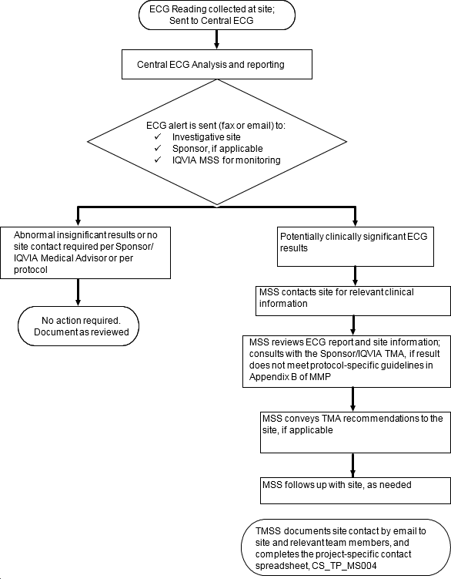
C

Appendix B: Escalation and Resolution of Follow up of ECG Alerts



Page 6 of 6
Copyright © 2006, 2009, 2011, 2013, 2016, 2018, 2019 IQVIA. All rights reserved. The contents of this document are confidential and proprietary to IQVIA Holdings Inc. and its subsidiaries. Unauthorized use, disclosure or reproduction is strictly prohibited.

Standard Operating Procedure Approval Signature(s)
This is a representation of an electronic record that was signed electronically in Content Server.
This page is the manifestation of the electronic signature(s) used in compliance with the organization’s electronic signature policies and procedures
Refer to Signatories CV for Business Title.

UserName: Ferrari, Antonio (q844337) Title:
Date: Friday, 05 April 2019, 09:26 AM Eastern Time Meaning: Signing this Document Indicates My Approval
================================================

UserName: Calatayud, Emiliano (q703375) Title:
Date: Friday, 05 April 2019, 10:42 AM Eastern Time Meaning: Signing this Document Indicates My Approval
================================================

